DVB-I Extensions and 3GPP Service URLs - modernising service announcement and discovery
Thomas Stockhammer¹, Frédéric Gabin², Richard Bradbury³, Marc Hoffrichter⁴, and Daniel Silhavy⁵
¹Qualcomm Germany GmbH, Munich, Germany
²Dolby Labs, Paris, France
³British Broadcasting Corporation, London, UK
⁴ZDF, Mainz, Germany
⁵Fraunhofer FOKUS, Berlin, Germany

ABSTRACT
In January 2024, the DVB-I Service Discovery specification (ETSI TS 103 770 [3]) was updated to allow different distribution systems to be described within a DVB-I service instance. This was motivated by use cases developed by the DVB Project aimed at signalling 5G-based content delivery of DVB-I services, and deep analysis undertaken jointly with 5G-MAG members, but also addresses use cases beyond the initial motivation. The result of this work is published in ETSI-TR-103-972 [5].
At IBC2023, an initial version of the analysis was presented in [1]. With the updates now completed in ETSI-TS-103-770 [3], the use cases and scenarios can be fully implemented, describing MBMS/LTE-based 5G-Broadcast, 5G-Media-Streaming as well as hybrid scenarios in DVB-I service lists. The main concept is based on using URLs, annotated with a content type description as commonly used in Internet-based delivery. The new signalling mechanism not only permits 5G-based delivery systems to be described in a DVB-I service list, but also provides a generic way to add other delivery systems.
This paper introduces the concepts in more detail, explains the requirements for content delivery systems to be described in a DVB-I service list and provides examples beyond 5G delivery, for example HLS. In the context of this, we also introduce the 3GPP Service URL that is added in 3GPP Release-18 technical specifications to permit and support different ways to integrate 3GPP services into existing service layers and application frameworks, for URL-based service launch. We point to advantages and opportunities of such a flexible and modern approach and provide guidance on best practice. While the concepts are specified in DVB-I/3GPP technical specifications, the implementation and verification to support these functionalities in mobile system application frameworks, web browsers and other system platforms are ongoing in 5G-MAG. Initial experiences from trials are provided in the paper.

Introduction
Prior to COVID, DVB ran an internal study item on the relation of 5G and DVB. The main conclusion from this study was, that DVB should view 5G as an opportunity rather than threat and identify commercially and technically relevant synergies and cooperation modes. Based on these findings, in March 2020 DVB initiated the creation of commercial requirements for mobile network operators (MNOs) and broadcast network operators (BNOs) for delivery of DVB-I over 5G. The work culminated in the publication of DVB Bluebook C100 [4] on Commercial Requirements for DVB-I over 5G in July 2021. The major idea of the commercial requirements is shown in Figure 1. A DVB-I service layer including DVB-I service list offering, DVB-I content packaging using DVB-DASH and DVB-AVC, and possibly converted into a unidirectional IP multicast stream using DVB-MABR is delivered over 5G systems using the well-defined network reference points for 5G Broadcast and 5G Media Streaming (5GMS). Equivalently, on the receiver, the APIs are used to provide service offerings for a DVB-I client.
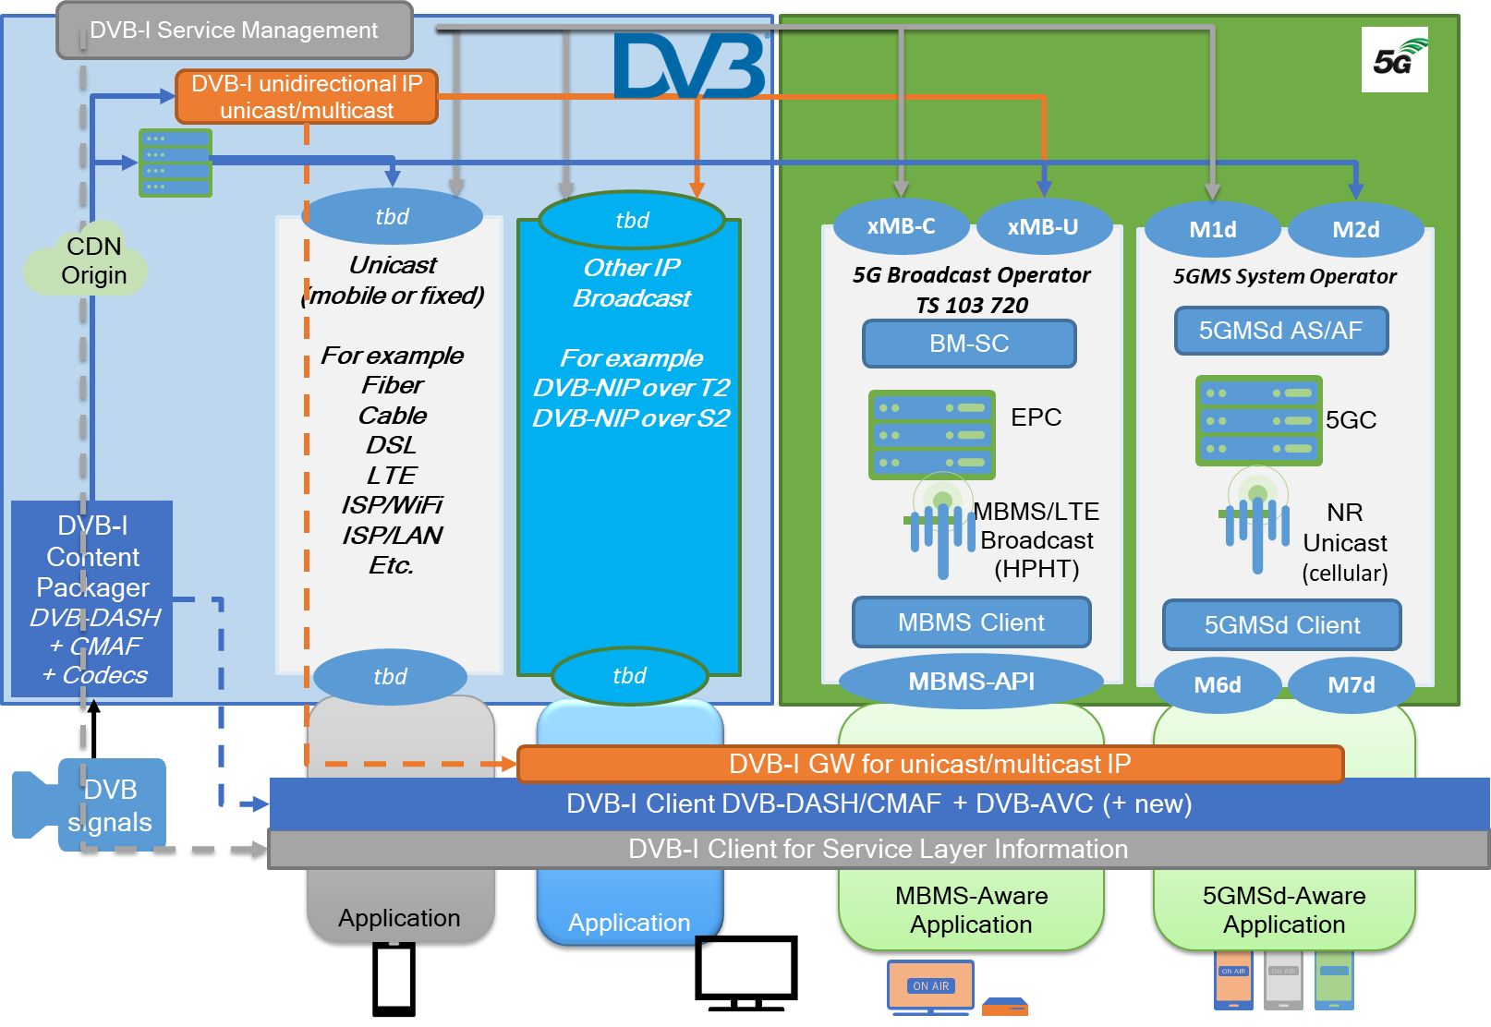
Figure 1 The basic idea of DVB-I over 5G – Modular systems supported by network-side reference points and client-side APIs for easy plug & play.
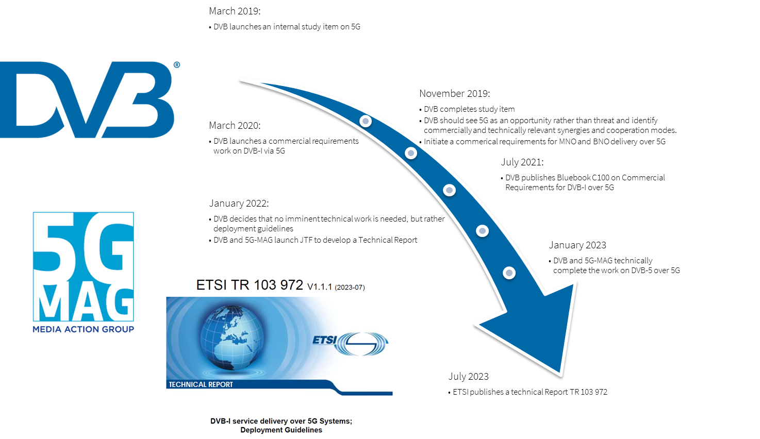
Figure 2 Developments in DVB and 5G-MAG regarding DVB-I and 5G
Based on the commercial requirements in C100, DVB and 5G-MAG from January 2022 onwards jointly developed Deployment Guidelines in ETSI TR 103 972 [5] that were finally published in July 2023. The timelines and deliverables are shown in Figure 2. The remainder of the paper focusses on the core findings in TR 103 972, the resulting extensions in DVB-I, recent work on 3GPP to further support the deployment, and the combination of the tools in initial trials.
Summary of Findings in TR 103 972 – DVB-I and 5G Deployment Guidelines
An overview of the puzzle pieces from 3GPP and DVB identified in the first version of the Technical Report can be found in Figure 3.
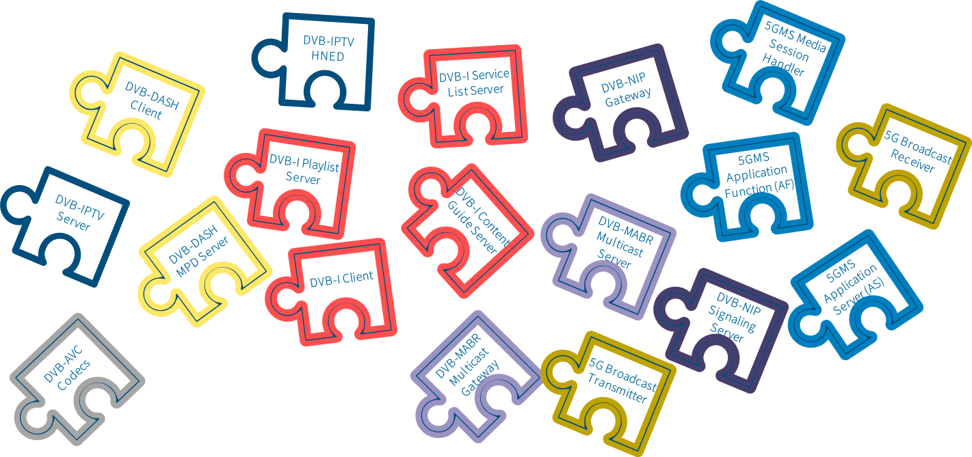
Figure 3 The DVB-I over 5G Puzzle Pieces
In TR 103 972, different scenarios are analyzed, in particular:
- Standalone DVB-I Service using 5G Broadcast: DVB-DASH & DVB-I via File Delivery
- DVB-I Service using 5G Media Streaming
- DVB-I service offerings simultaneously over broadcast and unicast
  - DVB-I via unicast and DVB-DASH via 5G Broadcast
  - Hybrid broadcast–unicast service scenarios
The scenarios are mapped to a general service architecture as shown in Figure 4 including the different components of the DVB-I system in the top, as well as components of the 5G System architecture and the 5G Broadcast and 5G Media Streaming architecture.
Figure 4 High-level architecture for DVB-I Services over 5G Systems according to ETSI TR 103 972 (Note: DVB-MABR and DVB-NIP variants not included)
In addition, each of the scenarios is mapped to call flows, including service provisioning and ingest, service discovery, service selection and reselection as well as service delivery. This includes network reference points and client APIs, as well as delivery interfaces as shown in Figure 4. Based on these findings and call flows, deployment guidelines and a gap analysis are provided to fully support the DVB-I services on top of different 5G delivery systems.
The TR concluded that DVB-I fulfills the purpose to run on top of different IP-access systems and can advantageously be combined with 5G (leveraging the network features, not being just a pure bit pipe). It enables new collaboration models between content providers/broadcasters and network operators, both 5G Broadcast and mobile. The design of the 5G System and DVB-I based on reference points and interfaces permits combination without requiring new specifications. The specifications and guidelines are supported by reference and open-source tools that permit rapid development of proofs of concept and timely trials. In summary: no architectural gaps were identified, and only the following gaps in signalling:
- the ability to provide a generic Service Locator in DVB-I that points to a 5G Broadcast Service using MBMS/3GPP URLs.
- the ability to signal service classes in 5G Broadcast that point to DVB-I metadata services (service lists, content guides, etc.)
These extensions are explained in more detail below.
Extensions to DVB-I
In order to address the identified gaps in DVB-I, the Service Discovery and Programme Metadata for DVB-I specification in TS 103 770 [3] was updated in early 2024 to introduce the ServiceInstance/IdentifierBasedDeliveryParameters element. This signals the parameters of the relevant delivery system for this service instance in the form of a Uniform Resource Locator (URL). While the DVB-I Client may parse the identifier into its constituent elements in order to route it to an appropriate handler, the semantics of individual parameter values are opaque to it. The identifier may be augmented with a content type that identifies the type of the service, for example DASH MPD or an HLS M3U8 to assist the DVB-I Client in routing the locator. Internet MIME type registration as defined in IETF RFC 6838 [6] may be used to define content types of the identifier, possibly even supported with further sub-parameters such as profiles or codecs.
While this generic identifier was introduced to support different 5G services, it is by no means limited to 5G. TS 103 770 provides an example of how this identifier may be used to refer to an HTTP Live Streaming (HLS) service – and other services to be described by DVB-I service lists without requiring any updates to the DVB-I specifications. DVB still argues whether this was by design or by mistake!
Secondly, it was identified that for the carriage of DVB-I metadata in MBMS (and hence 5G Broadcast) it is advantageous to allow receiver-side filtering for the different types of metadata document. For this purpose, the DVB-I specification in TS 103 770 defines three new service classes for the metadata as shown in Table 1.
Table 1 Service class identifiers for DVB-I Metadata
Service class identifier | Content conveyed in corresponding MBMS User Service
urn:dvb:metadata:serviceClass:DVB-I_Service_List:1 | A single DVB-I service list document, as specified in clause 5.5.1 of TS 103 770
urn:dvb:metadata:serviceClass:DVB-I_Content_Guide:1 | DVB-I Content Guide documents, as specified in clause 6.10 of TS 103 770
urn:dvb:metadata:serviceClass:DVB-I_Service_Instance:1 | The media assets of a DVB-I service instance further parameters of which are indicated in its MBMS User Service Description.

3GPP Media Delivery and Service URL
In many cases, UE applications, for example a DVB-I Client, are not necessarily assumed to have knowledge of 5G-based media delivery. In general, the media service is announced in some portal application running in the UE, for example a portal web page or similar electronic service guide, as a link published on social media, or as an entry in a DVB-I service list. In all cases, the service announcement includes a media service entry point URL. When a service is selected in the Portal Application, it launches the URL of the corresponding media service entry point. In the general case, the media service entry point is consumed by a separate Media Service Application in the UE which takes responsibility for interacting with the UE modem to stream the media (downlink or uplink) of the selected media service. The Android UE Operating System allows a URL to be used by one application to launch a specific other application or background service on the same UE [7]. An application or service wishing to handle certain URI prefixes does so by declaring a suitable intent filter in its application manifest (a so-called web URI intent declaration). Android recognises links, in particular Android App Links that use the HTTP and HTTPS schemes, and allows the application to designate itself as the default handler of a given type of link. Android App Links leverage HTTP URLs and association with a website.
Figure 5 3GPP Media Delivery Architecture – Session Handling and Media Delivery
Exactly this property is exploited to designate the Media Session Handler, introduced in the 5G Media Delivery architecture as shown in Figure 5, as the designated application to handle 3GPP Service URLs. The launch of a 5GMS session using a 3GPP Service URL is shown in Figure 6. In this procedure, the Application is not assumed to be a 5GMS-Aware Application.
Figure 6 Baseline procedure for 3GPP Service URL Handling
After service provisioning, the application provider creates a service URL that is shared with the UE-resident application. Once the application selects the service, the Media Session Handler is launched automatically, and possibly communicates with a corresponding Application Function (AF) in the network to obtain additional service parameters. Based on this Service Access Information, the corresponding Media Stream Handler, e.g. a DASH or HLS player, is launched and Inter-Process Communication (IPC) is established between the Media Stream Handler and the Media Session Handler to exchange relevant session parameters.
According to 3GPP TS 26.510 [8], 3GPP Service URLs used to initiate media delivery sessions take the following form:
http[s]://launch.3gppservices.org/{service}/{service_id}?{query_parameters}
The structure of the 3GPP Service URL is pre-determined (for example to be designated to the Media Session Handler in an intent-based flow) a service type discriminator service, service identifier service_id and an optional path. In addition, an optional query suffix part may specify additional service launch parameters formatted as a set of <key>=<value> pairs or flags. The Media Session Handler performs decomposition of the URI into the prefix and suffix and extracts relevant parameters, for example the service to be launched. Details for 5G Media Streaming parameters are provided in 3GPP TS 26.512 [9]. To cater for cases where a Media Session Handler is not (yet) installed on a particular UE, the service provider offering the 3GPP Service URL also provides a resolution of the 3GPP Service URL in the network, for example hosted in the Application Function, that redirects the invoking application to a resource that the requesting application is able to process, for example a media file, URL to an MPD, etc.
Two specific service identifiers are defined for MBMS to support launching MBMS and 5G Broadcast services, as defined in TS 26.347 [10]. If the service parameter in the URL indicates mbms or mbms-rom, then the service is an MBMS service and the MBMS URL handling procedures and query parameters apply. This allows to 5G Broadcast services to be launched using well-defined HTTP URLs.
Building a System – Plug ‘N PlaY and Summary of first pilot projects
Using the concepts defined in DVB and 3GPP, and leveraging the reference tools developed in 5G-MAG and DVB, and by partners in the 5G Broadcast domain, in March 2024 the world’s first standards-conforming demo of 5G Broadcast integrated into the DVB-I service framework on a commercial smartphone was shown during DVB World 2024. The implementation architecture is shown in Figure 7. 5G Broadcast transmissions from the Ismaning/Munich broadcast tower were added as service instance to a DVB-I service list and the DVB-I client is updated to select services included in the 5G Broadcast signals. The 5G Broadcast signals were integrated in the service list of the German DVB-I Pilot, whereby the instances for 5G Broadcast are given highest priority and will hence be selected by 5G Broadcast capable receivers but ignored by regular TV sets or smartphones.
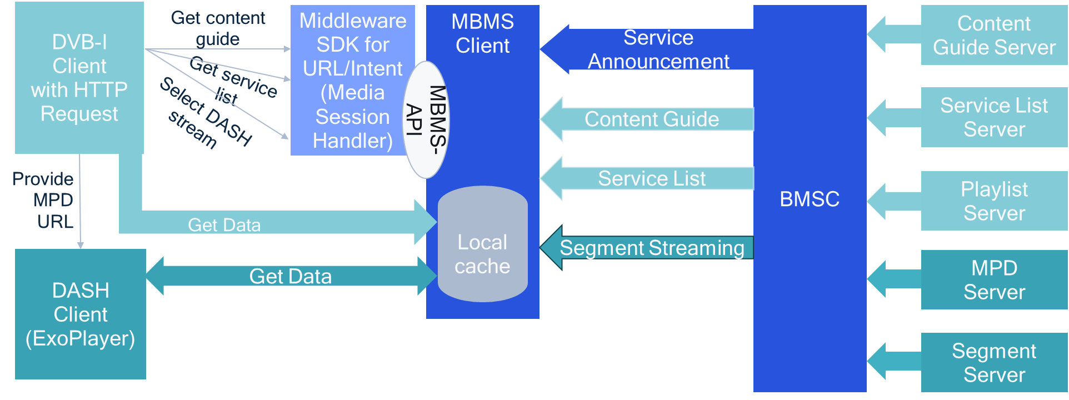
Figure 7 Implementation Architecture – DVB-I services over 5G Broadcast
The implementation provided a proof of concept to show the combination of modern service layers with modern web and Internet transport systems. The design is also aligned to support native Android and progressive web apps, an important requirement in order to reach a wide variety of target devices. This first showcase still worked with a separate service list that offered the 5G services exclusively. The architecture did not yet allow the device to be integrated into the existing service list of the German DVB-I pilot, so in order to be able to address the 5G app, an intermediate step was implemented via a so-called media presentation app that is integrated into the service list.
This use case was expanded for the Fraunhofer Media Web Symposium by adapting the frontend so that a service instance directly delivers 5G parameters. The frontend interprets this instance and if it has a higher priority than, for example, a DVB-DASH instance or a DVB-S2 instance, the intent is generated and executed in the player (and not in the media presentation app). Since the service list of the German DVB-I pilot is still on release A177r4, the XML element <IdentifierDeliveryParameters/> could not yet be used, but instead the already established element <OtherDeliveryParameters/>. It is expected that for IBC 2024, the German service list is up to date with Bluebook A177r6 and the <IdentifierDeliveryParameters/> may be used. This service list can also be used for all other DVB-I devices. In order to be able to start the 5G app (or intent), a DVB-I frontend needs a some capability mechanism to recognize whether it is able to play an existing 5G service instance or to ignore it. The listing below shows an example service from MWS, but taking into account the new identifier based delivery parameters as developed in DVB-I and expected to be available for IBC:
<Service version="3">
<ServiceInstance priority="5">
<DASHDeliveryParameters>
<UriBasedLocation contentType="application/dash+xml">
<URI>https://mcdn.daserste.de/daserste/dash/manifest.mpd</URI>
</UriBasedLocation>
</DASHDeliveryParameters>
</ServiceInstance>
<ServiceInstance priority="4">
<IdentifierBasedDeliveryParameters contentType="application/dash+xml profiles='urn:dvb:org:dash'">https://launch.3gppservices.org/mbms-rom &tmgi=901056&serviceArea=40201&frequency=68616&subCarrierSpacing=1.25&bandwidth=8&serviceId=%22DVB-I DASH service%22</>
</IdentifierBasedDeliveryParameters>
</ServiceInstance>
<ServiceName>Das Erste HD</ServiceName>
<ProviderName>ARD</ProviderName>
<RelatedMaterial>
<HowRelated href="urn:dvb:metadata:cs:HowRelatedCS:2020:1001.2"/>
<MediaLocator>
<tva:MediaUri contentType="image/png">https://itv-api.ard.de/ardstart/img/services/28106.png</tva:MediaUri>
</MediaLocator>
</RelatedMaterial>
<RelatedMaterial>
<HowRelated href="urn:dvb:metadata:cs:LinkedApplicationCS:2019:1.1"/>
<MediaLocator>
<tva:MediaUri contentType="application/vnd.dvb.ait+xml">https://itv-api.ard.de/xml.aitx?sid=28106</tva:MediaUri>
</MediaLocator>
</RelatedMaterial>
<ServiceType href="urn:dvb:metadata:cs:ServiceTypeCS:2019:linear"/>
<ContentGuideSourceRef>iSIMS</ContentGuideSourceRef>
<ContentGuideServiceRef>tag:mitxp.com,2021:eit1.1019.10301</ContentGuideServiceRef>
</Service>
A few initial aspects around implementation experiences:
- Client Architecture: In both initial trials, the frontend and middleware were strictly separated from each other, and DVB-I frontend player is a Progressive Web App (PWA). This was considered as the most complex scenario, but as it was verified under the restrictions of a PWA/browser environment, it is expected that no problems arise when using other platforms such as native apps or HbbTV Op Apps etc. The frontend and the middleware must be "married" so that inter process communication between two apps is possible. In a fully integrated app, inter-app communication does would not have to be taken into account, but the full range of functions and support must be represented, which will certainly have an impact on the budget.
- Service List access: Unicast HTTP protocols are an integral part of DVB-I. The protocol requires a web-server and the client must be able to handle it. Generally, it is beneficial that a client has access to unicast to acquire full service lists. If not possible, the service list may be provided as a broadcast carousel and the be served from a local HTTP server.
- File Carousel: In a 5G broadcast stream, URLs or files can be transmitted using a file carousel. Here, the runtimes and referencing must be taken into account. If the referencing is done via a URL, it must be ensured that the middleware is registered to this URL in order to intercept it and return the content. For example, a content guide could be referenced via the URL: https://localhost:4095/contenguide/zdf.xml.
- Signaling the content guide: If there is no internet connection, the content guide cannot be called in the traditional way. However, it is possible to integrate the content guide into the 5G stream via a file carousel. For booststrapping quickly, the service list needs to be carouseled in an appropriate frequency.
- The 5G Broadcast middleware provides a suitable DASH or M3U8 manifest depending on the service ID. The exact URL for this should be accessible via a defined endpoint. The streaming server should idle to save battery life when no consumer is connected. If a client requests the aforementioned endpoint, the streaming server can start.
- Security aspects: The service list and also the content guides will most likely be rewritten by the middleware. This can pose a security risk. Therefore, the service list should always be digitally signed and the certificate signed by an agreed trust authority.
CONCLUSIONS
In this paper, we provided an overview of all technical enablers to integrate 5G-based delivery including 5G Media Streaming and 5G Broadcast into DVB-I based services. The designs are aligned well with modern service discovery and delivery systems. Seemingly, all functionalities are in place and more variants to support different scenarios and use cases are expected in due course, leveraging existing reference tools in 5G-MAG and DVB. First trials show the feasibility and benefits of the integration of 5G with DVB-I, explaining how DVB-I and 5G Brpadcast are complementary and synergistic technologies.
ACKNOWLEDGEMENTS
The authors would like to thank the colleagues in 3GPP, DVB and 5G-MAG for their continuous support in developing unifying specifications across different ecosystems, in particular Paul Higgs, Jordi Gimenez, Kurt Krauss, Johann Mika and Klaus Kühnhammer. Also special thanks to the colleagues dedicated to have implemented the first proof of concept, in particular Lars Oestreicher and Remo Vogel.
REFERENCES
- R. Bradbury, F. Gabin and T. Stockhammer, "DVB-I Service Delivery over 5G Systems", September 2023, IBC Conference, https://www.ibc.org/technical-papers/ibc2023-tech-papers-dvb-i-service-delivery-over-5g-systems/10254.article
- ETSI TS 103720 V1.2.1, “5G Broadcast System for linear TV and radio services; LTE-based 5G terrestrial broadcast system”, EBU, June 2023.
- ETSI TS 103 770: "Digital Video Broadcasting (DVB); Service Discovery and Programme Metadata for DVB-I"
- DVB Bluebook C100: "Commercial Requirements for DVB-I over 5G"
- ETSI TR 103 972: "DVB-I service delivery over 5G Systems; Deployment Guidelines".
- IETF RFC 6838: "Media Type Specifications and Registration Procedures"
- Android Developer Documentation: "Handling Android App Links", https://developer.android.com/training/app-links
- 3GPP TS 26.510, "Media delivery; interactions and APIs for provisioning and media session handling"
- 3GPP TS 26.512, "5G Media Streaming (5GMS); Protocols"
- 3GPP TS 26.347, "Multimedia Broadcast/Multicast Service (MBMS); Application Programming Interface and URL"

